A2G Inc. is a multi-business corporation with seven business divisions. These vary in size and range from relatively small (less than 100 employees, 50 million dollars in annual sales) to quite large (10,000 employees, 2 billion dollars in annual sales). The businesses span a range of industries some of which are related (e.g. heavy earth moving equipment, construction) and others which are not (e.g. publishing services). Corporate Head Quarters (HQ) has 20 employees currently. The newly appointed CEO of A2G Inc. has asked you to analyze role of corporate HQ and recommend what changes, if any you would make to how it is organized.

Recall from Section 1 that the goal of the corporate strategist is to exploit synergies through administrative control that cannot be replicated by mere investors. Head Quarters, where the corporate strategists reside, is ultimately the custodian of corporate advantage. Its goal is to ask (and help answer) the question of why the collection of businesses they administer is worth more than what they would be worth if operated independently.

We will use “HQ” to refer not only to corporate head-quarters in a multi-divisional corporation but in fact to any administrative unit making strategic decisions that cut across multiple businesses. These could be regional, national or divisional headquarters, or indeed the holding company of a portfolio of companies (as in a business group). To the extent any of these entities are responsible for ensuring that the set of businesses they administer creates more value than what they would if operated independently, they are in effect pursuing corporate advantage. In addition HQ may also be the organizational or physical location of shared service units.

This section focuses on the mechanisms of influence, or the Influence Models, available to HQ to achieve this objective, given a fixed portfolio composition. This focus is critical in order to understand each component of corporate advantage clearly; HQ’s create corporate advantage through the decisions they make about portfolio composition (the topics of sections 4-9), but also about how they manage the businesses that exist in the portfolio (this section and section 10, which focuses on the organizational macro-structures used to manage the portfolio), as well as how they manage the process of bringing businesses into the portfolio (sections 12 and 13). Of course, there are complementarities between decisions about what value chains go into the portfolio (i.e. the scope of the multi-business organization, deriving from the diversification and refocusing choices covered in Sections 4 and 7), the organizational macro-structure (section 10) and the influence model that HQ uses to derive synergies and generate corporate advantage (this section). We will elaborate on these linkages at the end of this section. To begin with, we focus on the models of HQ influence on a portfolio of businesses, given its scope and organizational macro-structure.

In Section 1, we said corporate advantage comes broadly from either portfolio assembly (“selection”) or portfolio modification (“synergy”). We defined “synergy” as an umbrella term to describe the various ways in which the cash flows and discount rates of businesses in a portfolio can be modified through administrative influence. Synergy is the means through which corporate advantage is created relative to a typical investor who can assemble the same portfolio of investments (without exercising administrative influence over them, as he lacks decision rights to do so).

In this section we explain how the appropriate Influence Model for HQ—defined as the way HQ influences individual businesses in the portfolio—is contingent on the choice of how corporate advantage is being pursued.

HQ influence in portfolio assembly (selection)
A corporate strategy based on pure portfolio assembly (without modification of businesses in the portfolio) requires being able to systematically spot and access undervalued opportunities, as well as exit businesses when good opportunities to do so arise. The strategic capabilities needed for such an approach include:
- Environment scanning for new opportunities: this primarily involves business strategy expertise, such as understanding sources of competitive advantage, industry structure, regulatory environment, technological and demand changes.
- Expertise at M&A and alliances: while these are important vehicles for broadening the scope of the multi-business organization (as discussed in sections 5 and 6 in this document), they are also useful within businesses to build them out or strengthen them. As such the insights from Section 5, 6, and 12 and 13 are all relevant for M&A and alliances conducted within an industry to strengthen an existing business.
- Expertise at divestiture: Sections 7 and 8 describe the logic of refocusing through various forms of divestiture, and these should actively be under consideration by a HQ with a pure portfolio assembly approach to corporate advantage.

These strategic capabilities could either be embedded among explicitly designated roles/units, or performed informally by a team with multiple responsibilities.

Even if there was no modification of businesses after entry into the portfolio, nonetheless a multi-business corporation, by virtue of being a corporation (and particularly if it is a publicly listed one) requires some Corporate Management Functions (CMF), such as Treasury, Risk management, Taxation, Financial Reporting, Company Secretary & Legal counsel, Government relations and Investor relations. Details on these CMF’s can be found in the Appendix to this section. They represent what are sometimes known as the “obligatory staffing” of HQ. If there are any benefits in Consolidating and Combining these functions across businesses, then there may be some (almost inadvertent) synergy effects. In a holding company structure, most of these CMF’s are not strictly necessary at HQ as they would most likely exist at the individual company level (and definitely so if the individual company is listed, as in Asian business groups), so one could in principle have a very lean Corporate HQ in these cases.

HQ influence in business modification (synergy)
Everything we say above about the influence of HQ in pure portfolio assembly models is applicable also to cases where corporate advantage is being pursued through business modification (synergy). Furthermore, there is a whole variety of additional means of influence to consider when the HQ is pursuing a synergy approach to corporate advantage.

Much of current thinking on how HQ’s “parent” their businesses owes its origins to the pioneering work of Goold, Campbell, and Alexander (1994). A distillation of their work suggests two critical dimensions of influence of HQ on businesses in the portfolio of the multi-business organization—stand-alone vs. linkage influence, and evaluative vs. directive influence (see Figure 11.1).

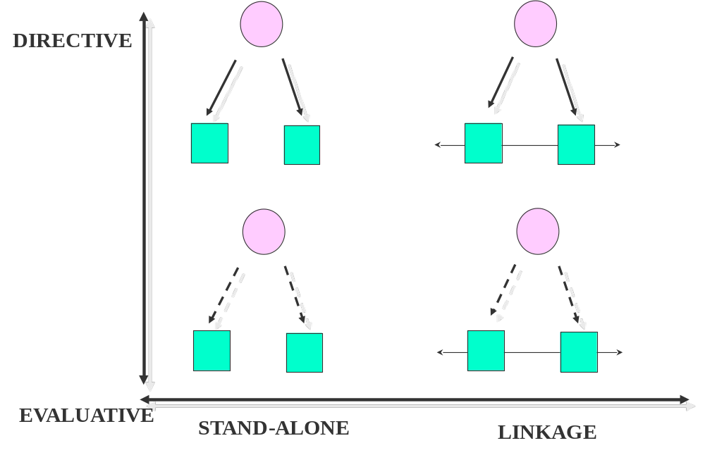
Figure 11.1 HQ influence has two dimensions

- Horizontal dimension: Stand-alone vs. linkage

This dimension indicates the nature of horizontal relationships in the portfolio—those between businesses in a portfolio. Under stand-alone influence, HQ does not encourage any meaningful business-to-business relationships. HQ influence is felt solely through to a vertical HQ-to-business relationship. The businesses independently benefit from or use a valuable resource or capability that is located at HQ. Under linkage influence, HQ encourages businesses to work together in alliance like fashion. HQ influence is felt through the business-to-business relationship fostered and administered under the supervision of HQ (in addition to any vertical influence HQ employs).

Note that synergies play a role in both models of influence. In linkage influence, HQ exerts authority to enable the extraction of synergies of all kinds (Consolidation, Combination, Customization and Connection) between businesses. In stand-alone influence, HQ is the locus of intangible resources and capabilities that have Connection/Customization synergies with the business value chains. These include corporate brand; management expertise; functional expertise in Finance, HR, M&A, strategic alliances, and other best practices. Alternately, one may think of these synergies as Consolidation or Combination effects arising from creating these intangibles once at HQ instead of several times in the portfolio (i.e. for each business).

When HQ is also the organizational or physical location of centralized functions (e.g. to extract Consolidation and Combination synergies across businesses through shared services units) whose use requires some coordination between businesses, then the influence lies somewhere between pure stand-alone and pure linkage influences. For instance IT procurement and real estate management functions across different businesses may be centralized at HQ; in all other matters, the businesses may operate independently from each other.

- Vertical dimension: Directive vs. evaluative
This dimension indicates the nature of vertical relationships in the portfolio—those between businesses and HQ. Directive influence refers to the control that HQ exerts on businesses by directly influencing their strategic decisions and actions through approving, vetoing, or ordering them. When HQ uses directive influence, resource allocation (e.g. capital budgeting) tends to be a rigorous process with a lot of scrutiny and vetting by HQ before budget approvals. Capital budgeting becomes the key process through which the strategic decisions at the business level are overseen and controlled by HQ in this model of influence. This is accompanied by close monitoring of implementation of decisions via operational targets. In contrast, evaluative influence refers to control by HQ of businesses primarily through setting financial performance targets and evaluating outcomes; the business units may however have a high degree of autonomy in terms of their decisions. The analogy is to incentivizing behaviour (directive control) vs. outcomes (evaluative control). Essentially, the locus of strategy making and implementation in each business remains at the business level for evaluative control and moves to HQ for directive control.

These are of course extreme cases, with intermediate points possibly being much more common (e.g. HQ decides, business leadership implements, HQ evaluates outcomes as a measure of implementation success). HQ for instance may be actively involved both in guiding and approving business unit strategy as well as managing performance through targets and incentives. GE under Jack Welch was famous for a rigorous capital budgeting and performance evaluation process. Note that synergies play a critical role in both of directive and evaluative models of influence , and that both are consistent with a “strong” (influential) HQ.

Models of HQ Influence: The four prototypes
The role and composition of HQ will naturally look different in these different models. Directive influence models tend to rely on strategic planning capabilities concentrated at HQ. Further, directive approaches can more easily pursue one-sided synergies (in which one business gains more than the other loses, leaving the aggregate portfolio better off). Evaluative influence relies more on financial control and performance management, with high degrees of delegation and autonomy on strategic decision making. One–sided synergies may be harder to achieve in such settings, and the focus may be mostly on two-sided synergies.

Further, standalone influence models tend to involve portfolios of businesses that look quite distinct from each other to the external observer (prompting the label “Conglomerate”) because the synergies across them mostly occur at the back end of the value chains and possibly in corporate management functions. In linkage models, since the portfolio is such that it supports active management of inter-business synergies by HQ (e.g. shared manufacturing, R&D or sales and distribution), external observers often see such portfolios as being more “related”.

Combining the two horizontal approaches (stand-alone vs. linkage) with the two vertical approaches (evaluative vs. directive) yields four prototypes of HQ influence (see Table 11.1). Note that these models of influence are just that—models. Reality involves hybrids and combinations.

Table 11.1: Prototypes of HQ influence
Directive | “Turnaround”  - HQ takes active role in BU level strategy making  - Emphasis on operational targets  - Connection/Customization synergies between HQ and BU’s based on intangibles | “Sharing resources”  - HQ takes active role in BU level strategy making  - Emphasis on operational targets  - Connection/Customization synergies between HQ and BU’s based on intangibles  - One sided or two sided synergies from Consolidation/Combination/Customization/Connection across businesses
Evaluative | “Portfolio”  - BU’s have autonomy in strategic decision making  - Emphasis on financial targets  - Connection/Customization synergies between HQ and BU’s based on intangibles | “Setting context”  - BU’s have autonomy in strategic decision making  - Emphasis on financial targets  - Connection/Customization synergies between HQ and BU’s based on intangibles  - Two sided synergies from Combination/ Connection/Customization across businesses
 | Stand-alone | Linkage

Stand-alone, evaluative
The standalone, evaluative (SE) influence model comes closest to the pure portfolio assembly model, yet differs from it in the sense that there is some attempt at indirect modification of businesses through evaluative control. Financial target setting and performance management are key activities in the HQ in this case, besides any corporate management functions (CMF) that are necessary to meet regulatory requirements. The management capabilities that underlie evaluative control constitute the intangible assets that generate Connection/Customization synergies with the businesses; the cost of creating and hosting these are economized by hosting them once at HQ (rather than replicate across businesses). Berkshire Hathaway under Warren Buffet comes close to this model. “Portfolio planning” and “Financial control” are terms often used to describe the activities of HQ in this model of influence. The Chinese firm Fosun manages their portfolio in a broadly similar manner, and the businesses are globally distributed.

Stand-alone, directive
The standalone, directive (SD) influence model is associated with a restructuring orientation. Like pure portfolio assembly, the selection of businesses is an important part of the HQ activity, but unlike pure portfolio assembly, there is an active attempt at modifying businesses through Directive control. “Restructuring” and the “PE model” are terms often used to describe the role of HQ. The directive attempts can include changes in business model, business strategy, staffing, and compensation. Strategic planning and turnaround management are key HQ activities in this model, besides any corporate management functions (CMF) that are necessary to meet regulatory requirements.

The management capabilities that underlie directive control constitute the intangible assets that generate Connection/Customization synergies with the businesses; the cost of creating and hosting these are economized by hosting them once at HQ (rather than replicate across businesses). HQ may also be the physical or organizational location of tangible assets in the form of shared services functions that create consolidation/combination synergies across businesses in back office and IT functions. While this proto-type bears some similarity to the Private Equity/ Leveraged Buyout model of business improvement, there is a significant difference; eventual exit from the business is not presumed and indeed may be difficult if shared service functions have been created (in fact a joke often told about unsuccessful conglomerates is that they were PE firms that forgot to exit). Conglomerates such as Hanson and Tyco were famous in yesteryears for following this model. Danaher Corporation, the U.S. equipment manufacturer is an instance of this approach in contemporary times, though its scope is less broad than what one would consider a typical conglomerate.

Linkage, directive
The linkage, directive (LD) influence model explicitly focuses on actively managing operational synergies through linkages between businesses through directive control. Besides the Corporate management Functions, the HQ in organizations following this model is likely to have strategic planning teams, corporate development functions (M&A and/or Alliance teams), and Centre’s of Expertise (in areas like best practices, procurement etc.). HQ may also be the physical or organizational location of shared services functions that create consolidation/combination synergies across businesses in back office and IT functions. “Sharing tangible and intangible assets” and “Corporate development capabilities” are labels often associated with such a model. An organizational culture that allows linkages to be exploited across businesses is often seen as a critical ingredient for success within this model, because even in a directive approach there are limits to what the HQ can formally force the businesses to do in terms of collaboration. Technology and FMCG companies like Cisco systems and P&G illustrate this model of influence.

Linkage, evaluative
Finally, the linkage, evaluative (LE) influence model explicitly focuses on managing operational synergies through linkages between businesses, but does so passively rather than actively. Rather than direct businesses to realize synergies between them, the goal instead is to create a context that allows businesses to collaborate on synergy realization. While HQ’s will still host corporate development functions (M&A and/or Alliance teams), and Centre’s of Expertise (in areas like best practices, procurement etc.), their use by business units is more likely to be elective rather than imposed. Instead a strong Corporate HR function with an emphasis on building the informal organization that glues the businesses together may be prominent. “Setting context”, “Cultural engineering” and “Special projects” are terms often associated with this model of HQ operation. It would seem somewhat more difficult for this influence model to work across geographies because of the cultural and time-zone differences.

Resource allocation by HQ
The influence of the HQ is ultimately exerted on the basis of HQ’s resource allocation decisions, regardless of which HQ influence model is adopted; ultimately HQ has the power to allocate resources to the businesses, not the other way round.

Resource allocation in directive control takes the form that major capital expenditure commitments (and therefore strategic investments) cannot be made without approval and rigorous screening, regardless of the need for capital rationing. In evaluative control, capex requests are granted semi-automatically if they clear hurdles, but individual performance related incentives depend on past performance.

Resource allocation by HQ may do better or worse than resource allocation by individual investors via the capital markets. HQ ostensibly has access to better information about each business and the decisions rights to enforce actions by their subordinates that enhance the value of these investments. At the same time, it has access to a smaller set of alternatives and is prone to conflicts of interest between HQ and shareholders. We focus on providing guidelines for HQ decision making about resource allocation under the assumption that the decisions are motivated by enhancing the value of the firm.

Resource allocation in multi-business organizations involves decisions about how to spread investment across a portfolio of businesses, and not only whether or not to invest in a particular business. This raises two challenges: synergy and uncertainty. First the businesses in a multi-business organization are not independent of each other; there are interactions between them. These could be of the form of synergies or dis-synergies. How should one take these into account when allocating resources across the portfolio? Second, from the field of finance we have well developed theories for resource allocation under risk (i.e., the future is uncertain but we can describe the possible outcomes and the probability of each of these outcomes occurring). These produce heuristics such as investing in projects only if their internal rate of return exceeds their weighted average cost of capital, or to only invest in positive NPV projects. Under fundamental uncertainty (i.e., the future is uncertain but we do not know all the possible outcomes or their probabilities of occurring), organizations researchers have recognized that the problem is one of managing the well-known exploration-exploitation tradeoff: How to balance investment in businesses likely to do well (exploitation) vs. investment in businesses with uncertain outcomes (exploration), which may turn out to be the “next big thing”? If the only way in which one can learn about the value of a business opportunity is by trying it, then some degree of exploratory investment is optimal. But how much?

The Synergistic Portfolio framework tackles both synergies and uncertainty in resource allocation decisions, see Figure 11.2. The two axes correspond respectively to:
Horizontal axis—Incoming benefit: how much does this business gain or lose in value from belonging to this portfolio?
Vertical axis—Outgoing benefit: how much value do the other businesses gain or lose from the presence of this business in the portfolio?

The total value created by a business being in the portfolio is the sum of the scores on the horizontal and vertical axes. A proxy for incoming benefit could be a comparison of the NPV of this business when operating within the portfolio, with the expected enterprise value when it is spun-off. A proxy for outgoing benefit could be the comparison of the sum of the NPV’s of other businesses in the portfolio, with the expected enterprise value of the corporation after the focal business has been spun-off.

When both incoming and outgoing benefits are positive, the business is two sided synergistic (top right quadrant). However, one could still want businesses in the portfolio even when they are not in this quadrant. The 45 degree line through the origin, sloping downwards from left to right, shows the threshold of acceptance for investment opportunities in the portfolio; if they are above it to the right, it is worth investing in them. This is because both loss leaders (high outgoing benefit, low but negative incoming benefit) and profit leaders (high incoming benefit, low but negative outgoing benefit) improve the overall value of the portfolio. However, altruists (high and negative incoming benefit, low and positive outgoing benefit), misfits (negative incoming and outgoing benefits) and parasites (high and negative outgoing benefit, low and positive incoming benefit) do not, and should receive little investment or considered for divestment.

The goal of resource allocation in the portfolio thus is to push businesses further away from the origin toward the top and right, away from the investment threshold. Movement of each business in the portfolio over time can be traced through this diagram.

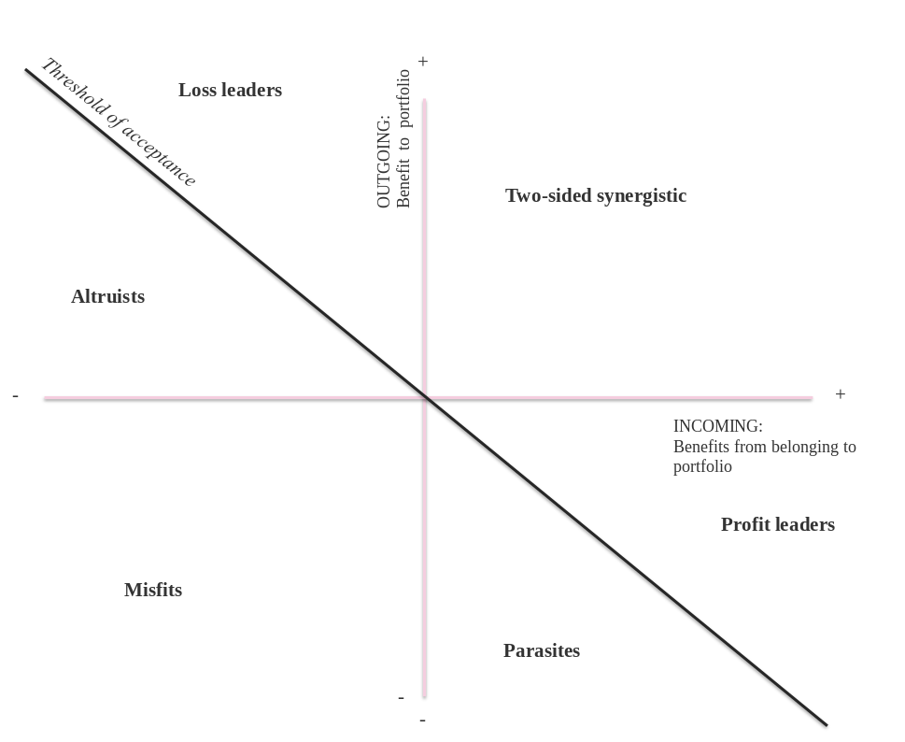
Figure 11.2 Synergistic portfolio framework

However, we must still account for the uncertainty of investment opportunities. We classify each business as best as we can but because such classification depends on assumptions about an uncertain future we are bound to make errors. A tractable way to think about this involves distinguishing errors of omission (believing an opportunity was below the threshold when in fact it was above) from those of commission (believing an opportunity was above the threshold when in fact it was not).

First, you should try to minimize both errors by obtaining good information, making sensible assumptions, and following a structured decision process. However, completely eliminating both errors is impossible. To avoid commission errors, you would invest only if you are fully convinced that the business will do well but that would imply plenty of omission errors (i.e., missing out investments in businesses that would have been worthy of investments). To avoid omission errors, you would invest even if you are unsure about the viability of a business but that would imply plenty of commission errors (i.e., money wasted on businesses that turn out to go nowhere). Second, therefore, you should try to minimize the more costly of the two errors. Omission costs increase relative to commission costs if there is a unique opportunity to acquire, a decline in the availability of alternatives, a temporary regulatory loophole, or a technology with increasing returns or network externalities Higher costs of omission (relative to costs of commission) stimulate exploration. Figure 11.3 shows how the threshold of acceptance should change location as the costs of omission and commission rise.

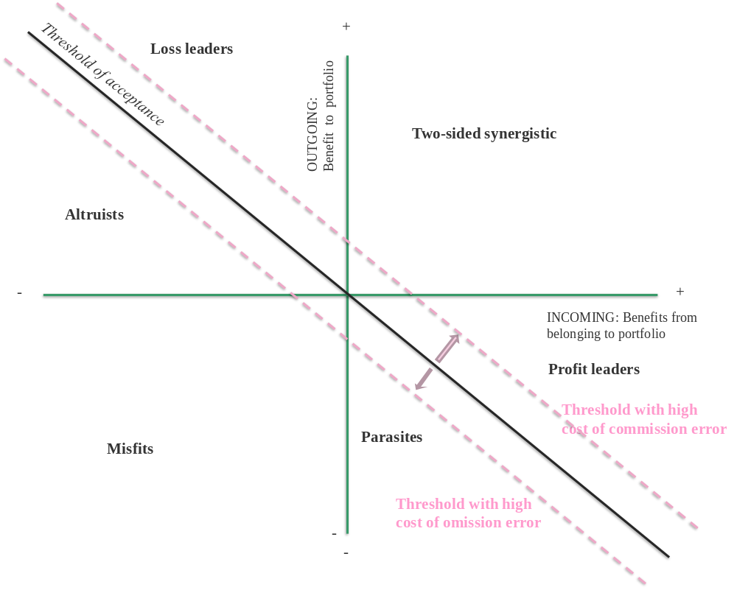
Figure 11.3 The cost of omission and commission errors influence the threshold of acceptance

Application: A2G
A2G has seven business division, four of which are in related industries ((A) heavy earth moving, (B) construction, (C) building materials, and (D) infrastructure) and three that are not ((E) publishing services, (F) textile manufacturing, and (G) casinos).

The role of corporate HQ can be analyzed along two dimensions. The first dimension is horizontal, i.e., whether corporate HQ influences stand-alone improvements or linkage benefits of the businesses. For the divisions A, B, C, and D linkage benefits are plausible because they operate in related industries. For divisions E, F, and G, stand-alone improvements is the best that can be hoped for because of the lack of apparent operational synergies between the divisions.

The second dimension is vertical, i.e., directive vs evaluative control. For division A, B, C, and D (active in related industries) linkage benefits mostly arise from bundling products and service in order to sell complete projects to customers (i.e., Connection synergies). These synergies are mostly two-sided because everyone benefits. Hence, there is no need for corporate HQ to be actively involved. Furthermore, because the upstream value chains of A, B, C, and D are quite different, there is no benefit consolidating them at the corporate HQ level. An evaluative approach seems sufficient for A, B, C, and D. This is also the more logical approach for E, F, and G because of the big diversity in industries—corporate HQ is unlikely to be able to add much value.

Accordingly, a cluster approach in which A-D are in one cluster, with E, F and G operating more or less autonomously seems indicated. Further, this suggests an evaluative approach focusing on stand-alone improvements for all divisions and linkage benefits for some is appropriate for A2G.

In terms of resource allocation, you seek information on how much each division gains from being part of A2G (incoming benefit) and how much the rest of A2G gains from having that division in the portfolio (outgoing benefit). The CEO provides you with the data in Table 11.2, which shows for each business the enterprise value computed in two ways: current value within the portfolio (NPV of the going concern), and value of a spin-off (NPV, multiples of comparable stand-alone firms, IPO pricing, or other techniques used to compute standalone value, also see section 12 on M&A valuation).

Table 11.2 Enterprise values before and after hypothetical spin-off (in mln $)
 | Enterprise value
 | Division |  | Rest of corporation
Division | Before a spinoff | After a spinoff | Before a spinoff | After a spinoff
(A) heavy earth moving | 150 | 100 | 830 | 600
(B) construction | 230 | 200 | 750 | 500
(C) building materials | 180 | 160 | 800 | 810
(D) infrastructure | 80 | 90 | 690 | 640
(E) publishing services | 120 | 80 | 860 | 865
(F) textile manufacturing | 110 | 160 | 870 | 890
(G) casinos | 110 | 100 | 870 | 950

You calculate the incoming and outgoing benefit for each division (see Table 11.3) and plot these in an expanding horizons framework (see Figure 11.4). You realize that the portfolio of A2G consists of 1 misfit (textile manufacturing), 1 parasite (casinos), 1 loss leader (infrastructure), 2 profit leaders (publishing services and building materials), and 2 two-sided synergistic (heavy earth moving and construction). As expected, the related divisions within the cluster benefit more from and provide benefits to the portfolio than the unrelated divisions do.

Table 11.3 Benefits from and to A2G for each division (in mln $)
Division | Enterprise value of business |  | Incoming benefit | Enterprise value of rest of corporation |  | Outgoing benefit | Classification
 | Before a spinoff | After a spinoff |  | Before a spinoff | After a spinoff
(A) heavy earth moving | 150 | 100 | 50 | 830 | 600 | 230 | Two-sided  Synergistic
(B) construction | 230 | 200 | 30 | 750 | 500 | 250 | Two-sided Synergistic
(C) building materials | 180 | 160 | 20 | 800 | 810 | -10 | Profit leader
(D) infrastructure | 80 | 90 | -10 | 900 | 850 | 50 | Loss leader
(E) publishing services | 120 | 80 | 40 | 860 | 865 | -5 | Profit leader
(F) textile manufacturing | 110 | 160 | -50 | 870 | 890 | -20 | Misfit
(G) casinos | 110 | 100 | 10 | 870 | 950 | -80 | Parasite

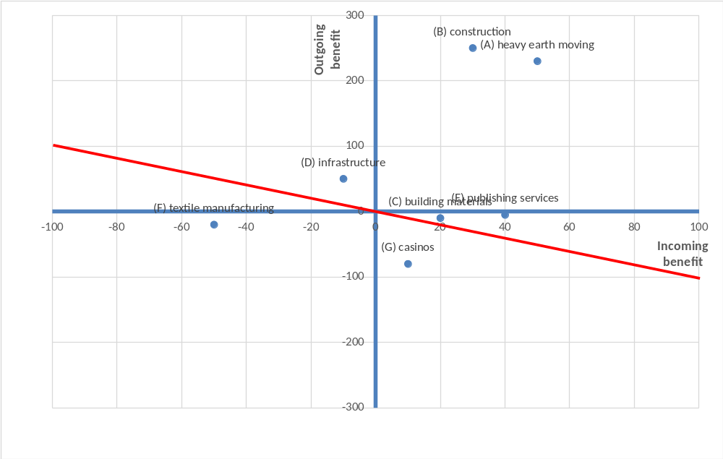
Figure 11.4 Synergistic portfolio for A2G

In terms of capital allocation for the next year, recall that A2G follows an evaluative not directive approach, and is not particularly cash constrained but investors have been pushing for higher dividends. Furthermore, most businesses are relatively mature (so that reasonably good information is available about their prospects) and stable (so that it might be possible though not necessary to reallocate resources from one business to another). Further, there is no obvious gain from exploration, as the costs of commission (i.e. making a bad investment) is probably larger than the cost of omission (i.e. ignoring a good business opportunity).

With these ideas in the mind, we can now turn to investment decisions by business. Textile manufacturing stands out in a negative sense: it does not benefit from the portfolio and reduces the value of the portfolio. You can suggest to minimize funding and consider a divestiture for this business. While casinos is a thriving business, the rest suffers from casinos due to the negative reputation from gambling. You again suggest to cut funding and to consider removing casinos from the portfolio altogether. Next, publishing services gains significantly from the portfolio at a small cost to the portfolio. You maintain funding at last year’s level but flag that their success depends on other divisions in the portfolio. You leave it to them to decide how to do it. On balance, the related businesses are doing well so you maintain funding, though you make additional funds available for projects that increases outgoing benefits (e.g., for building materials) or incoming benefits (e.g., infrastructure).

Thus, there are two divisions that appear to be struggling in the sense they would be worth more after spin-off than in the portfolio: textile manufacturing (misfit) and infrastructure (loss leader). The former you suggest to restructure or divest, though the latter should continue to receive funds because it is adding value to the corporation. In contrast, on the face of it, casinos (a parasite) is doing well but it is unclear why it should remain in this corporate portfolio, and you would consider divesting it too. Note that these decisions are uniquely driven by the synergistic portfolio framework; an approach that ignores the interactions within the portfolio would (erroneously) recommend divesting textile and infrastructure, and keeping Casino’s.

<APPLICATION ENDS>

Basic facts about corporate HQs
- Studies decomposing the variance in profitability to business unit, corporate parent, and industry level factors have found that the corporate parent factor represents around 10 to 20% of total variance (and 20 to 25% of explained variance), using the most recent techniques (McGahan and Porter 2002). This is in between that for industry and that for business unit. However, it is now understood that this may be a significant underestimate of the impact of corporate HQ because of data limitations and the methodology, which mainly has to do with the fact that many business unit specific factors actually originate through HQ decisions.

- The size of corporate headquarters relative to the total size of the corporation varies enormously across sectors and geographies. Primary drivers of differences in HQ size is the scale of shared service functions provided to the businesses in the portfolio, as well as the extent of linkage influence exercised by HQ.

- The cost of corporate headquarters in large multi-business corporations can range from 2%-7% of sales (Roland Berger 2013) but may be much higher in terms of operating profit. Holding company HQ’s are relatively cheaper than other kinds of HQ’s.

- Most multi-business companies use some form of corporate portfolio management frameworks. However, their use in actual capital allocation decisions seems limited, and the missing role of portfolio levels effects (i.e. synergies and dis-synergies between businesses) in most existing frameworks is recognized.

Common mistakes to avoid
- Directive control will only work if the HQ has sufficient competence to understand the specifics of each business. It is unlikely to work in highly diverse portfolios.

- Over-estimating the value of a linkage approach can occur if HQ has a poor understanding of the value chains of the respective businesses and the sources of potential synergies between them. The linkage approach, like the directive approach is thus less likely to work in portfolios with high diversity.

- The flip side to the previous point is that HQ may overlook the fact that one sided synergies will not materialize unless there is directive control. Left to their own devices, business units will only pursue two-sided synergies, but the loser in a one-sided synergy project will have little incentive to collaborate unless HQ intervenes to force a re-distribution of gains.

- The pressures towards uniformity of influence models across businesses are quite high. They arise from the need to maintain perceptions of equity across businesses as well as limits on managerial capacity at HQ to entertain different and possibly conflicting dominant logics within HQ. However, it is useful to recognize that these pressures can lead to inappropriate levels of uniformity, and can be deal with through portfolio restructuring (e.g. divestment) or reorganization (e.g. clustering into homogenous clusters within which a single influence model can be applied).

- Offering centralized shared functions at HQ is value adding only when there are synergies from consolidating across businesses and significant transaction costs if these functions are outsourced; else HQ may end up forcing business to procure internally from HQ that which can be procured more cheaply through external providers.

Frequently asked questions
Q1. How is the synergistic portfolio framework different from the Boston Consulting Group’s portfolio allocation framework?
Corporate portfolio management frameworks such as the Boston Consulting Group’s growth-share matrix (famous for its “Stars/Cash Cows/Question Marks/Dogs”), the GE-McKinsey framework, or the Business Attractiveness Matrix of Campbell, Whitehead, Alexander and Goold (2014) are all driven by the same basic idea: the businesses in a corporate portfolio can be compared to each other on two basic dimensions, namely the attractiveness of the industry the business is in, and the competitive advantage of the business within that industry. These frameworks identify the conjunction of high industry attractiveness and high competitive advantage as the “sweet-spot” for investment, while also recognizing the challenge of balancing exploration and exploitation; they encourage investment in businesses that are in attractive industries but have not yet established a strong competitive advantage. For instance, in the BCG framework, the injunction is to do some exploration (the question marks), but to curtail losses by divesting the dogs, and to exploit the stars by investing in them again. The cash cows provide the cash flows for these investments (a somewhat archaic view of the source of funds, as it ignores capital flows from outside the corporation). However, the approach is very much anchored in business strategy; the axes of the matrix represent competitive advantage within an industry and industry attractiveness respectively, but ignore the most important element of corporate strategy: synergies. Indeed none of the popular corporate portfolio management frameworks account properly for synergies in the sense of a business benefiting from belonging to a portfolio, and of the portfolio benefiting from the inclusion of a business. The synergistic portfolio framework tackles both – uncertainty and synergies.

Q2: How disciplined are corporate HQ’s at actually allocating resources? Don’t politics and power play an important role?
In practice, the evidence on capital allocation within multi-business corporations suggests
- High levels of stability over time: What a division got last year and what it will get this year is highly correlated (>0.90).
- A strong tendency towards “corporate socialism”: The number of divisions in the firm is negatively correlated with capital allocation to a division.

Many reasons have been suggested for these results, including the possibility that investment opportunities across the portfolio change slowly, cognitive biases, political pressures and fairness concerns. A key point to bear in mind is that with organizational resource allocation (as opposed to an individual’s resource allocation, say over a portfolio of investments) the information needed to make these allocation decisions is distributed across individuals whose interests diverge from the organizations’ as well as from each other’s interests; unanimity over the appropriate allocation of resources may not exist (Kang, Burton & Mitchell, 2011).

There is no simple solution to these issues besides recognizing that discriminating allocations may matter most when there are stable and large differences across investment opportunities and in situations of standalone influence. In linkage influence models, particularly if differences in investment opportunities are smaller, it may be acceptable to invest more equally rather than equitably, in order to preserve collaboration and harmony within the portfolio.

Q3. Don’t the choices of influence model and organizational structure (Section 10) have to be made jointly?
Yes. The complementarities between these choices are driven by one core factor: organizing the businesses into units with measurable profit and loss is useful when a) adopting an evaluative control approach (because evaluation is easier for units that have measurable profits or losees), as well as b) when the influence is primarily standalone rather than linkage (because each units profits are not directly influenced by others). These links between organizational macro-structure and influence models are summarized in Table 11.2 and Figure 11.5.

Table 11.2 The link between organizational structure and influence model
Corporate advantage based on | Organizational structure | Influence model
Selection | Autonomous business units/ companies | Stand-alone, Evaluative
Selection & synergies | P&L Units organized by business, geography; or functional units (cost centres); hybrid & matrix organization | Stand-alone or Linkage; Directive or Evaluative.
Figure 11.5 Prototypes of HQ influence and macro-structure

Q4. How does the synergistic portfolio framework relate to the HQ influence models?
In general, the synergistic portfolio framework is applicable under all influence models. Regardless of which influence model, HQ ultimately has to decide how to allocate resources across the businesses. Furthermore, each of the influence models is consistent with synergies in the portfolio, which is what the synergistic portfolio framework aims to exploit. More specifically, we do not anticipate that the acceptance threshold or the distribution of businesses across different categories varies systematically by influence model.

Q5: Is it necessary for the same influence model to be used for every business in the portfolio? What if the portfolio is highly varied?
An implicit premise in the discussion of influence models we presented above is that the same influence model is used for the entire portfolio. However, this may not be a reasonable premise in multi-business organizations with significant diversity in portfolio composition. A solution to this problem of large diversity, is to partition the portfolio into clusters (or “segments” or “domains”) with greater homogeneity within than between clusters. This allows different influence models to be applied to different clusters. For instance a cluster of businesses could be defined on the basis of:
- Stronger synergies within clusters than between; these could include synergies that require linkage (e.g. knowledge sharing or cross-selling between businesses) or standalone approaches (e.g. common brands)
- Greater scope for application of common management techniques and models within a cluster, which is the case when there are similarities across businesses within a cluster in terms of:
  - sizes of capital investment projects
  - time spans of investment projects
  - sources of risk
  - management capabilities required by different businesses
  - key success factors
  - stages in their industry life cycles
  - competitive positions occupied by each business within its industry
  - performance goals and measures
  - time horizons for measuring performance

When such similarities exist, they create what is known as a “dominant general management logic” which binds the businesses together and makes it easier to administer them jointly. The challenge is that HQ may still be constrained in terms of how many different dominant logics can be simultaneously accommodated by it. A strategy of clustering the portfolio is thus likely to require some division of labor within the HQ in terms of cluster specific responsibility, and consequently at least a two-tiered reporting structure within HQ.
It is useful to document the influence model as it applies to each business within the portfolio in terms of a “responsibility chart” or “delegation contract”. This document explicitly states what decisions are to be taken by the business management, which one are the prerogative of HQ, and which ones require approval by (or informing of) HQ but are ultimately taken at the business level.

References
For more on variance decomposition studies, see:
Bowman, E. H., & Helfat, C. E. (2001). Does corporate strategy matter? Strategic Management Journal, 22(1), 1-23.
McGahan, A. M., & Porter, M. E. (2002). What do we know about variance in accounting profitability? Management Science, 48(7), 834-851.

On the size and location of HQs, see:
Birkinshaw, J., Braunerhjelm, P, Holm, U., & Terjesen, S. (2006). Strategic Management Journal, 27(7), 681-700.
Collis, D., Young, D., & Goold, M. (2007). The size, structure, and performance of corporate headquarters. Strategic Management Journal, 28(4), 383-405.

For more on corporate portfolio management tools, see:
Campbell, A., Goold, M., Alexander, M., & Whitehead, J. (2014). Strategy for the corporate level: Where to invest, what to cut back and how to grow organisations with multiple divisions (2nd ed.). San Francisco, USA: Jossey-Bass.
Goold, M., Campbell, A., & Alexander, M. (1994). Corporate level strategy: Creating value in the multi-business company. New York, USA: John Wiley.
Nippa, M., Pidun, U., & Rubner, H. (2011). Corporate portfolio management: Appraising four decades of academic research. Academy of Management Perspectives, 25(4), 50-66.
Pidun, U., Rubner, H., Krühler, M., Untiedt, R., & Nippa, M. (2011). Corporate portfolio management: Theory and practice. Journal of Applied Corporate Finance, 23(1), 63-76.

For more on internal capital markets, see:
Maksimovic, V., & Phillips, G. M. (2007). Conglomerate firms and internal capital markets. In B. E. Eckbo (Eds.), Handdocument of Corporate Finance (423-479). Amsterdam, The Netherlands: Elsevier.
Stein, J. C. (1997). Internal capital markets and the competition for corporate resources. Journal of Finance, 52(1), 111-133.

Appendix: Description on Corporate Management Functions (CMFs)
- Treasury
- The core functions of a corporate treasury includes:
  - Cash management: includes planning, account organization, cash flow monitoring, managing bank accounts, electronic banking, pooling and netting as well as the function of in-house bank.
  - Liquidity planning and control
  - Management of interest, currency, and commodity risks: involves control of these risks, as well as the documentation of hedging transactions.
  - Procurement of finance and financial investments: including money dealing, working capital finance, and also factoring.
  - Corporate finance: comprises medium and long term financing, particularly capital market instruments, ABS, group financing, credit, leasing, promotion instruments, and shareholders’ loans.
  - Contacts with banks and rating agencies.
- Risk management
- The core functions of risk management include:
  - Establishing Context: This includes an understanding of the current conditions in which the organization operates on an internal, external and risk management context.
  - Identifying Risks: This includes the documentation of the material threats to the organization’s achievement of its objectives and the representation of areas that the organization may exploit for competitive advantage.
  - Analyzing/Quantifying Risks: This includes the calibration and, if possible, creation of probability distributions of outcomes for each material risk.
  - Integrating Risks: This includes the aggregation of all risk distributions, reflecting correlations and portfolio effects, and the formulation of the results in terms of impact on the organization’s key performance metrics.
  - Assessing/Prioritizing Risks: This includes the determination of the contribution of each risk to the aggregate risk profile, and appropriate prioritization.
  - Treating/Exploiting Risks: This includes the development of strategies for controlling and exploiting the various risks.
  - Monitoring and Reviewing: This includes the continual measurement and monitoring of the risk environment and the performance of the risk management strategies.
- Taxation
- The core functions of taxation include:
  - Overseeing the completion of accurate tax returns to minimize the tax obligations of the organization.
  - Analyzing general ledger and related financial documents to ensure appropriate tax accounting is being performed.
  - Coordinating, facilitating and resolving all taxing authority inquiries and audits.
  - Keeping up to date with and advising others of organization-related tax regulations at the federal, state and local levels.
  - Implementation of tax planning arrangements.
  - Succession planning.
  - Remuneration packages planning.
- Financial Reporting
- The corporate CFO is responsible for the general control system of financial reporting. Corporate financial reporting is not only to show the financial statements of corporate but it includes to highlight important financial data and to show the application of financial policy. A good financial reporting will show true financial position of company. Corporate financial reports include the income statement, balance sheet, cash flow statement, statement of retained earning, and explanations of financial policies.
- Company Secretary & Legal Counsel
- The company secretary is responsible for the efficient administration of a company, particularly with regard to ensuring compliance with statutory and regulatory requirements and for ensuring that decisions of the board of directors are implemented. Despite the name, the role is not a clerical or secretarial one in the usual sense. The company secretary ensures that an organization complies with relevant legislation and regulation, and keeps board members informed of their legal responsibilities. Company secretaries are the company’s named representative on legal documents, and it is their responsibility to ensure that the company and its directors operate within the law. It is also their responsibility to register and communicate with shareholders, to ensure that dividends are paid and to maintain company records, such as lists of directors and shareholders, and annual accounts.
- A legal counsel, or general counsel, is the chief lawyer of a legal department, usually in a company or a governmental department. In a company, the person holding the position typically reports directly to the CEO, and their duties involve overseeing and identifying the legal issues in all departments and their interrelation, including engineering, design, marketing, sales, distribution, credit, finance, human resources, production, as well as corporate governance and business policy. General counsels often have broad roles encompassing crisis management, compliance reporting management and public policy advocacy. Many companies also hire in-house counsels to handle specialized tasks such as tax work, mergers and acquisitions, labor law and intellectual property, sometimes building in-house practice groups that rival the practices of major law firms.
- Government relations
- Government relations and public affairs are the types of public relations that deal with how an organization interacts with the government, with governmental regulators, and the legislative and regulatory arms of government. The two functions are often referred to as synonyms, but there are very minor differences. Government relations is the branch of public relations that helps an organization communicate with governmental publics. Public affairs is the type of public relations that helps an organization interact with the government, legislators, interest groups, and the media. These two functions often overlap, but government relations is often a more organization-to-government type of communication in which regulatory issues are discussed, communication directed to governmental representatives takes place, lobbying efforts directed at educating legislators are initiated, and so on.
- Investor relations
- Investor Relations (IR) describes the department of a company devoted to handling inquiries from shareholders and investors, as well as others who might be interested in a company's stock or financial stability. IR oversees most aspects of shareholder meetings, press conferences, private meetings with investors, investor relations sections of company websites, and company annual reports. The investor relations function also often includes the transmission of information relating to intangible values such as the company's policy on corporate governance or corporate social responsibility. The investor relations function must be aware of current and upcoming issues that an organization or issuer may face, particularly those that relate to fiduciary duty and organizational impact. In particular, it must be able to assess the various patterns of stock-trading that a public company may experience, often as the result of a public disclosure. The investor relations department must also work closely with the Corporate Secretary on legal and regulatory matters that affect shareholders. Finally, IR often has a role in crisis management of, for example, corporate downsizing, changes in management or internal structure, product liability issues and industrial disasters.

Zimmermann, T, & Huhle, F. (2013). Corporate Headquarters Study 2012 – Developing value adding capabilities to overcome the parenting advantage paradox
Adapted from http://www.treasury-management.com/article/4/121/1053/the-functions-of-a-corporate-treasury.html
Drawn from http://en.wikipedia.org/wiki/Enterprise_risk_management
Based on http://skills.salary.com/Job/Tax-Manager
Based on http://www.afrconsulting.co.uk/tax-manager-job-description/
Based on http://www.svtuition.org/2011/08/corporate-financial-reporting.html
Based on http://en.wikipedia.org/wiki/Company_secretary
Based on http://en.wikipedia.org/wiki/General_counsel
See Bowen, S. A., Rawlins, B., & Martin, T. (2015). Government relations and public affairs. In Mastering public relations (Section 10). Retrieved March 30, 2015 from http://catalog.flatworldknowledge.com/documenthub/reader/5573?e=bowen_1.0-ch10_s04
Based on http://en.wikipedia.org/wiki/Investor_relations

